Project Design Phase-II

DataFlow Diagram&UserStories

Date | 31 October 2025
TeamID | NM2025TMID01076
ProjectName | Laptop Request Catalog Item
Maximum Marks | 4Marks

Data FlowDiagrams:
AData FlowDiagram(DFD)isa traditionalvisual representation ofthe information flowswithina system.Aneatand clearDFDcandepictthe right amountof the system requirement graphically. It shows howdata enters and leaves the system, what changes the information, and where data is stored.
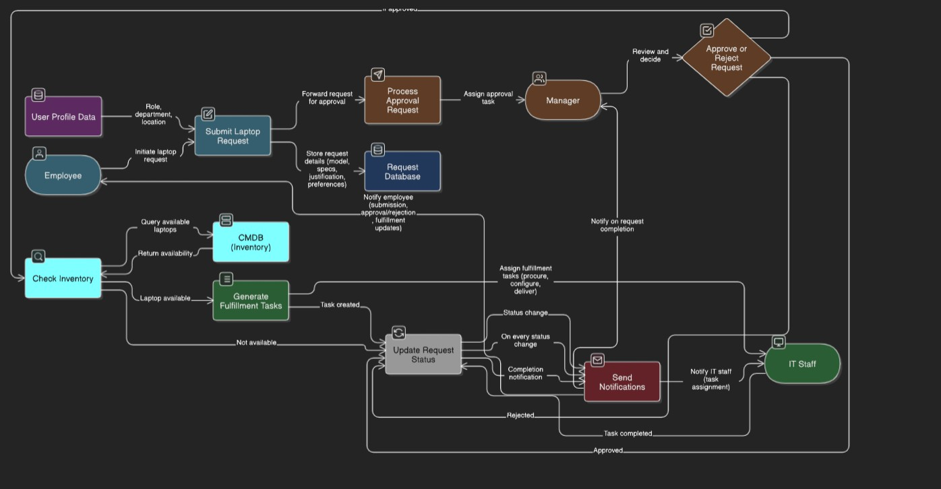

User Stories
Usethebelowtemplate to listallthe userstoriesforthe product.

UserType | Functional Requirement  (Epic) | UserStory Number | UserStory/Task | Acceptancecriteria | Priority | Release
Employee | LaptopRequest Form | USN-1 | As an employee, I can access a laptop requestforminServiceNowwithguidedfields. | 1. Form is accessible. 2. Fields are highlighted based on role. 3. Form hasaclearinstructionfor submission. | High | Sprint-1
Employee | LaptopRequest Form | USN-2 | Asanemployee,Iseerole-basedlaptop recommendations based on my job title. | 1. Form is accessible. 2. Fields are highlighted based on role. 3. Form hasaclearinstructionfor submission. | High | Sprint-1
Employee | FormDynamics | USN-3 | Asanemployee,Iseedynamicfieldsthat change based on my selections (via UI Policies). | 1. Form fields show/hide depending on selections (e.g., RAM options based onmodel).2.Formadjusts for user's laptop  preference. | Medium | Sprint-1
Employee | Form Functionality | USN-4 | Asanemployee,Icanresettheformto correct errors before submission. | 1.Formfieldsresettotheir default state. 2. No data loss from inaccuracies. | Medium | Sprint-1
Manager | Login | USN-5 | Asamanager,Icanapproveorrejectlaptop requests with comments. | 1.Emailnotificationssent to the approver and the requestor. 2. Approval logs are generated. 3. Manager can provide  reasons for approval/rejection. | High | Sprint-1
Employee | FormDynamics | USN-3 | Important:ThisistoberevisitedbasedonUI Policies specifics. | 1.Emailnotificationssent to the approver and the requestor. 2. Approval logs are generated. 3. Manager can provide reasons for  approval/rejection. | Medium | Sprint-2

UserType | Functional Requirement (Epic) | UserStory Number | UserStory/Task | Acceptancecriteria | Priority | Release
ITStaff | StatusTracking | USN-6 | Asanemployee,Icanseethereal-time status of my laptop request. | 1.Eachrequestshowsits status (e.g., "Pending Approval"). 2. Real-time updates are displayed on  thedashboard. | Medium | Sprint-3
ITStaff | Integration | USN-7 | AsITstaff,Icanseelaptopavailabilityfrom CMDB during request processing | 1.ITcanseeavailable models through IT’s dashboard. 2. CMDB  integratesseamlessly. | Low | Sprint-3
Employee | Notifications | USN-8 | Asanemployee,Ireceiveemailupdateson request approval or rejection. | 1.Emailnotificationsare sent immediately after approval/rejection. 2. Notifications include the  status | High | Sprint-2

